

Acrel-2000MG Microgrid Energy Management System Technical Proposal

Acrel Co., Ltd.
Declaration

All rights reserved. Without the written permission of our company, no paragraph or chapter in this manual can be extracted, copied or reproduced or transmitted in any form. Otherwise, all consequences will be borne by the violator.
Our company reserves all legal rights.

Our company reserves the right to modify the product specifications described in this manuall without prior notice.
Before placing an order, please consult your local agent to obtain the latest specifications of this product.

Directory
Directory I
Acrel-2000MG Microgrid Energy Management System Technical Proposal 2
Part I Acrel-2000MG System Manual 2
Chapter 1 System Overview 2
1.1 System Introduction 2
1.2 Technical Standard 2
1.3 Applicable Occasion 3
Chapter 2 Design Basis 4
2.1 Project Profile 4
2.2 User Requirement 4
2.3 Scope of Design 6
Chapter 3 Integrated Devices List of System 7
Chapter 4 Network Topology Structure 7
Chapter 5 Operating Environment and Basic Requirements 7
5.1 Requirements of Hardware Configuration 7
5.2 Software Operating Environment 7
5.3 Requirements of Container 7
Chapter 6 System Architecture 8
Chapter 7 System Function 9
7.1 Management of Supervisory Control 9
7.2 Data Acquisition 14
7.3 Event Alarm 15
7.4 Query of Historical Event 16
7.5 Curve Query 16
7.6 Operation Report 17
7.7 Report Statistics 17
7.8 Network Topology 18
7.9 Remote Control and Setup 18
7.10 Communication Management 19
7.11 Energy Management 19
7.12 User Authority Management 21
7.13 Self-diagnostics and Self-healing 22
7.14 Maintenance Function 22
7.15 Interface With Other Devices or Systems 22

Acrel-2000MG Microgrid Energy Management System Technical Proposal

Part I Acrel-2000MG System Manual

Chapter 1 System Overview

1.1 System Introduction
According to the requirements of new power systems and the target of carbon peak and carbon neutrality, Acrel Co., Ltd. has specially developed a new generation microgrid energy management system Acrel-2000MG after summing up foreign and domestic research and production experiences. The system of Acrel-2000MG can orderly manage and optimally control the sources (e.g. electricity, distributed photovoltaic and micro wind generator), the grid (enterprise internal distribution grid), the loads (fixed and adjustable loads), energy storage system and charging load of new energy vehicles of enterprise microgrids, realizing flexible interaction among resources, such as the power sources, the grid, the loads and the stored energy, under various objectives, and increasing the stable runtime of the system under multi-strategy control. Meanwhile, it implements a sound strategy of peak load shifting to promote the consumption of new energy, reduce the investment in power grid construction, and improve the power utilization by enterprises at lower operating costs, for energy saving and consumption reduction.
The microgrid energy management system is deployed using a tiered information architecture, in which the monitoring system consists of station control layer and bay layer. The station control layer is deployed with cluster control units for data processing, storage, monitoring and control of photovoltaic, wind generator, energy storage, rectifier and charging units in the station. The bay layer is deployed equipment with measurement and control functions (e.g. photovoltaic, wind generator and energy storage controllers, charging monitoring systems and billing control unit) to acquire and forward data and respond to commands from the station control layer. The network communication layer is responsible for communication between the bay layer and station control layer. The communication network uses standard Ethernet and TCP/IP communication protocols. The physical media can choose optical fiber, network cable, shielded twisted pair cable et al. The system supports Modbus RTU, Modbus TCP, CDT, IEC60870-5-101, IEC60870-5-103, IEC60870-5-104, MQTT, and other communication protocols.

1.2 Technical Standard
The solution comply with the following criteria, codes, industry standards and national standards:
GB/T7424.1-2003 The Part 1 of Optical Fiber Cables: Total Specifications
GB/T14549-1993 Power Quality: Harmonics Generated by the Public Grid GB/Z17625.6-2003
GB/Z17625.6-2003 The Electromagnetic Compatibility Threshold Limits Harmonic Currents Generated in Low-Voltage Supply Systems by Equipment with a Rated Current Greater than 16 A
GB50052-2009 Power Supply and Distribution System Design Specifications
GB50054-2011 Low Voltage Power Distribution Design Specifications
GB50065-2011 Grounding Design Specifications of AC Electrical Equipment
GB50150-2006 Electrical Equipment Installation Project: Electrical Equipment Handover Test Standards
GB50168-2006 Electrical Equipment Installation Project: Cable Line Construction and Acceptance Specifications
GB50169-2006 Electrical Equipment Installation Project: Grounding Equipment Construction and Acceptance Specifications
GB50208-2011 The Acceptance Specifications of Underground Waterproofing Project Quality
GB50217-2007 Electrical Project: Cable Design Specifications
DL/T5161.1～5161.17-2002 Electrical Equipment Installation Project: Quality Inspection and Evaluation Procedure
JGJ118-2012 Design Specifications for Building Foundations in Permafrost Regions
DLGJ154-2000 Cable Fire Prevention Measure Design and Construction Acceptance Standards
GA161-1997 Performance Requirements and Experimental Methods for Fire Blocking Materials
Q/GDW0214031-2014041-2010 Distribution Automation Technology Principles
Q/GDW0214035-2012010 Distribution automation remote terminal (DTU) technical specifications (I)
Q/GDW0214036-2012010 Distribution automation remote terminal (DTU) technical specifications (II)
Q/GDW553.1-2010 Based On Ethernet Passive Optical Network (EPON) – Part 1: Technical Conditions
Order No. 5 of the State Electricity Regulatory Commission: Electricity Secondary System Safety Prevention Regulations
Q/GDW1807—2012 Typical Design Specification for Terminal Communication Access Network Engineering

1.3 Applicable Occasion
Acrel-2000MG is suitable for enterprise microgrids such as industrial parks, resident communities, islands, charging stations, steel mills, chemical plants, cement mills, data centers, hospitals, and other places.

Chapter 2 Design Basis

2.1 Project Profile
The electric primary diagram is illustrated as follows:

Fig. 2.1 electric primary diagram

2.2 User Requirement
Requirements of system functions
1)Data acquisition and processing
Utilize measurement and control units, energy storage units and battery management systems to acquire and process the real-time information such as analog data and digital data.
Uploaded information of energy storage unit:
- Digital data: status of contactors and breakers at AC and DC sides, operating modes (e.g. grid-connected, grid-islanded, charging, discharging and standby), status of local control handle, etc.
- Analog data: voltage and current at the DC side, 3-phase voltage, current, active power and reactive power at the AC side
- Non-electricity data: temperature of IGBT, electric reactor, isolation transformer, etc.
- Operating conditions: protection enabling signal of energy converter, incident alarm signal
2)Incident alarm processing
The microgrid energy management system should have accident alarm and early warning alarm functions. Accident alarms include signals for tripped circuit breakers and activated protective devices caused by abnormal operation; early warning alarms include general equipment displacement, abnormal status information, or cell overvoltage, cell undervoltage, battery cluster overvoltage alarm, battery cluster undervoltage alarm, and abnormal software and hardware status of the computer monitoring system. Users can sort and filter relevant alarm signals according to their needs and group them into different alarm windows.
3)Operation monitoring
- The microgrid monitoring workstation is the primary means of communication between the energy storage monitoring system and the operator , while local manual control is reserved for emergency situations.
- The microgrid energy management system provide important parameters display necessary control buttons.
- The content of the graphical monitoring screen should include: general information of stored energy, main wiring diagram, PCS unit, monitoring of battery pack, operating information of battery cell, traceability of plan curve, communication conditions, etc.
- The graphical monitoring screen format should include: date and time in text or symbol, value of analog data, value of remote signal status, value of electric energy, real-time statistics, historical data, calculated data, etc.
- All screens should be able to be printed or copied directly to a printer, and the output should maintain the same effect as the monitor screen.
- It is preferred to control the following objectives: DC switches, electric control switches of different voltage classes, enable/disenable of main devices, etc.
- It is preferred to adjust the following objectives: PCS power setting, operating parameter setting of devices
- Control and regulation operations should be equipped with security measures such as operation permission checks, uniqueness checks for simultaneous operations, and position checks.
4) Online statistics
- Statistical calculations should be carried out for various conventional parameters (generation power, etc.) of the microgrid system operation, including the maximum and minimum values and their occurrence time, average value, number of times of overruns, time of overruns, overrun rate, and pass rate for the day, month, year, and time period.
- Statistical calculations should be performed on parameters such as the power generated by each wind turbine and the total power generated during the operation of the microgrid system, including comparisons of the power generated during different periods of time, as well as on a daily, monthly and yearly basis.
- Statistical calculations should be performed on the operating conditions of the main equipment in the microgrid system, including the number of normal operations and accidental tripping of circuit breakers, the number of times capacitors/reactors are switched in and out, etc.
- Daily operation report, monthly operation report, daily power statistics report, monthly power statistics report, annual power statistics report. The reports can be used to analyse the operating parameters of the power supply system and each circuit.
5) Self-diagnosis and self-restoring of the system
- With online diagnostic capability, diagnose the system's own hardware and software operation, alarm and record when abnormalities are found, and take automatic recovery measures when necessary.
- Extend the online diagnostics function to PCBs of local equipment
- The Self-restoring should be: The system automatically resumption of operation if the general abnormal status software. When the device has a backup configuration, the online device can automatically switch to the standby configuration when a hardware or software failure occurs. The self-restoring time shall not exceed 30s.
6)Maintenance functions
- Online maintain the database, and add, delete or modify various data
- Offline maintain the database, and re-generate the database with reasonable initialization value
- Easily transfer historical data upon request for long-term storage
- Simply generate and edit screens
7)Interface with other devices or systems
- The microgrid energy management system should establish communication interfaces with charging piles, energy storage PCS equipment, energy storage battery BMS equipment, wind turbine inverters, photovoltaic inverters and other individually set up equipment or systems within the microgrid system, and connect this equipment or systems to the microgrid energy management system for centralised monitoring and control, and the communication protocols should satisfy the requirements of standard communication protocols for power systems.
- The microgrid energy management system shall ensure data consistency and functional integrity when implementing interfaces with the above devices or systems.
8)Record function
Save various historical data such as voltage, current, power, electric energy, incidents and alarms for reference, analysis and printing.
9)Authority management
Boast the excellent user authority management function to avoid any unauthorized operation.

2.3 Scope of Design
Acrel-2000MG is a smart micro-grid energy management system designed for this project according to customer demands and project conditions. Devices and instruments are arranged as follows:
The integrated system composed of Acrel-2000MG microgrid energy management system and communication manager realises data collection, operation monitoring, operation management and optimal control, accident recording and analysis, relay protection, etc. for microgrid system in the process of operation, and completes the safe, high-efficiency and economic operation and management of enterprise microgrid.
The user needs to provide the following information: third-party equipment to be accessed in this project (by name, model, number, distribution location description), technical specifications of each device model, communication protocols and their point table. The communication protocol of the access device is Modbus RTU or Modbus TCP.
Note: Party A is responsible for primary devices, communication, installation and wiring of monitoring devices and power cables.

Chapter 3 Integrated Devices List of System
Appendix 3: List of Devices Integrated with the System.

Chapter 4 Network Topology Structure
Appendix 4 Network topology structure

Chapter 5 Operating Environment and Basic Requirements

5.1 Requirements of Hardware Configuration
For the Acrel-2000MG microgrid energy management system to work properly, the host computer where the system software is installed needs to meet the following hardware conditions:
CPU: 3.0GHz or above
Memory: 4GB or above
Hard disc: 1T or above
Graphics card: 1920*1080 resolution

5.2 Software Operating Environment
The software of microgrid energy management system Acrel-2000MG mainly runs on the Windows OS platform. And Windows 10 64-bit SQL Server 2008 R2 is compatible.
Software is authorized through an encryption lock, authorized software can run for long periods of time, and unauthorized software is limited to 8 hours of online running time.

5.3 Requirements of Container
The lightning protection and grounding design of the container in which this monitoring system is located shall meet the requirements of personal safety and normal operation of the electronic information system and shall comply with the relevant provisions of the current national standards “Lightning Protection Design Code for Buildings” GB50057 and “Lightning Protection Technical Specification for Electronic Information Systems in Buildings” GB50343. The environment in which the monitoring computer and communication collection device are located shall meet the following requirements:
Altitude: ≤2500m
Ambient temperature: 5℃-＋30℃
Maximum daily temperature difference: 25K
Relative humidity: 10%-80%, without condensate

Chapter 6 System Architecture
The system is designed with the hierarchical distributed structure (including equipment layer, network communication layer, and station control layer). The topology structure is detailed below:
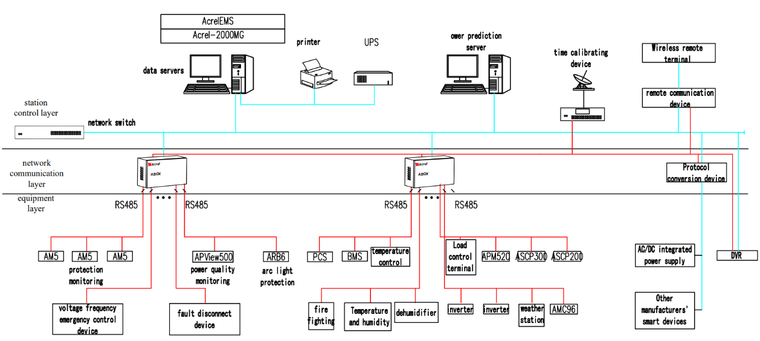
Fig. 2.1 Typical Networking of Microgrid Energy Management System
The microgrid energy management system mainly consists of a server, a switch, a communication management machine and other devices. It communicates with PV system, wind generation system, charging system or energy storage system via Ethernet for comprehensive energy management, device monitoring and other purposes.
The system has perfect battery management functions and rich external communication interfaces, which can realize real-time monitoring and control of the operation information of the energy storage system, charging system, photovoltaic system, wind turbine system and other intelligent equipment, including the collection of information such as voltage, current, temperature, pressure, flow rate and so on in the energy storage system, real-time monitoring, optimal management, intelligent maintenance and information query functions. Compared with conventional microgrids, the system needs to consider the energy storage system's service life. Therefore, try the best to prevent deep charging/discharging of the energy storage system.
In conjunction with the project's comprehensive considerations, the energy management strategy focuses on optimal economic operation. Develop an energy storage control plan based on real-time dynamic tariffs so that it charges when tariffs are low and discharges when tariffs are high, maximizing the revenue of the energy storage system. Control AC/DC module output power based on comparison of electricity demand and energy management unit information. Limit distribution power through energy coordination management to achieve economical operation, improve service capability, and reduce the distribution capacity of the previous level.
Design principles：
1)Extend the service life of energy storage system. In principle, implement one charge-discharge cycle every day.
2)Minimize the impact on the grid with the peak power lower than the setting value.
3)Sharply cut the electricity costs and consume the electricity during off-peak or normal hours as much as possible.

Chapter 7 System Function

7.1 Management of Supervisory Control
Acrel-2000MG microgrid energy management system meets the access of photovoltaic system, wind power generation, energy storage system and charging pile, conducts data collection and analysis around the clock, monitors the operation status and health condition of photovoltaic, wind power generation, energy storage system and charging pile, which is a management system integrating monitoring system and energy management. The system aims at economic optimization of operation on the basis of safety and stability, promoting the application of renewable energy, improving the stability of grid operation and compensating for load fluctuations; effectively realizing user-side demand management, eliminating the peak and valley differences between day and night, smoothing loads, improving the operating efficiency of power equipment and reducing the cost of power supply. It provides a new solution for enterprise microgrid energy management to provide safe, reliable and economical operation.
The system homepage provides real-time supervision of microgrid operation, including utility, photovoltaic, wind power, energy storage, charging piles and electricity loads, as well as revenue data, weather conditions, energy saving and emission reduction information.
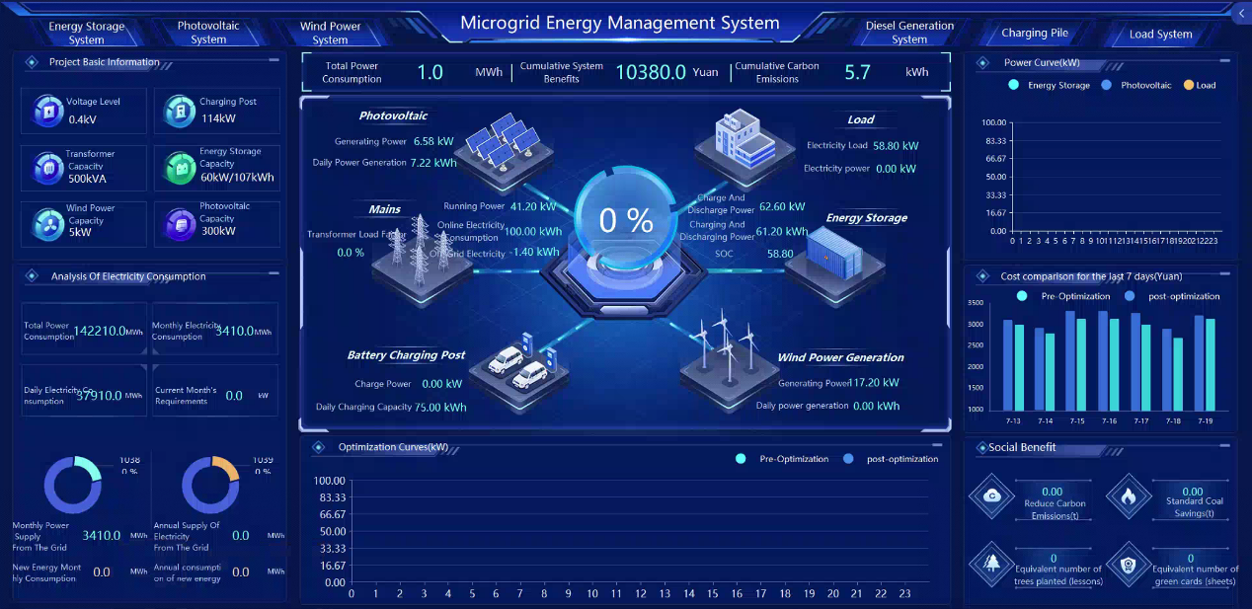
Fig. 7.1 Main Interface of Acrel-2000MG Microgrid Energy Management System
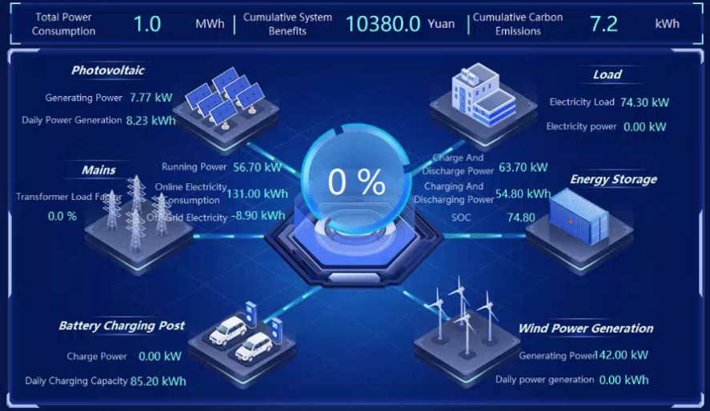
Fig. 7.2 Display of Microgrid Important Data
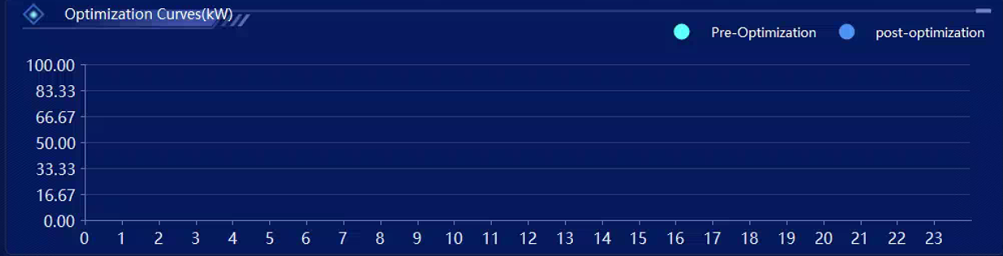
Fig. 7.3 Display of Optimization Curves
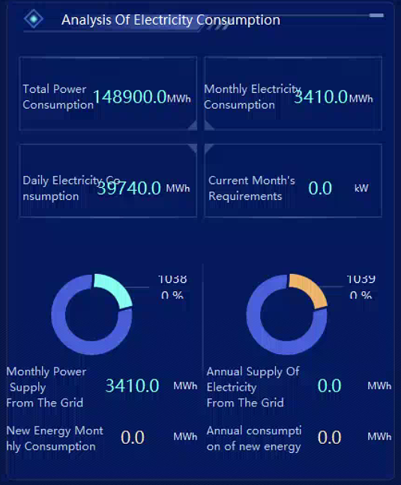
Fig. 7.4 Analysis of Electricity Consumption
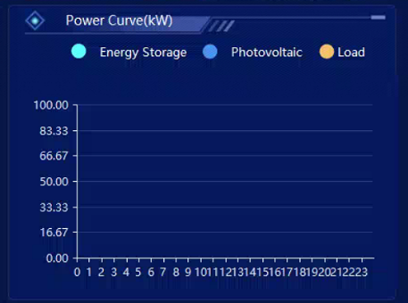
Fig. 7.5 Display of Power Curve
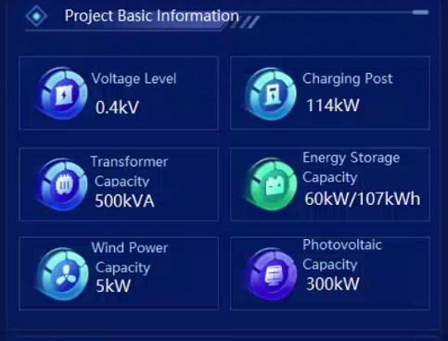
Fig. 7.6 Display of Project Basic Information
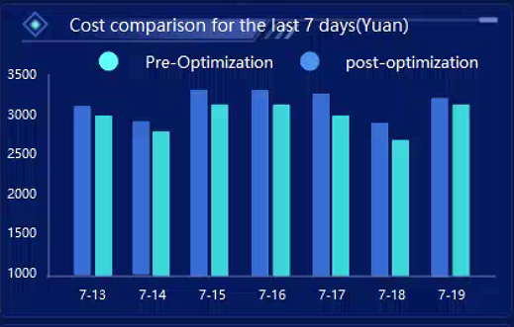
Fig. 7.7 Display of Cost Comparison
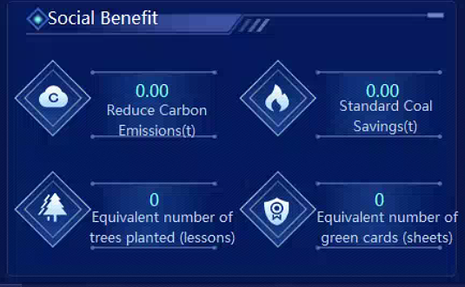
Fig. 7.8 Display of Social Benefit

7.1.1 Energy Storage System
For application with lithium iron phosphate(LPF) battery, the system provides some functions of online monitoring of energy storage battery, PCS bidirectional inverter et al to guarantee the residual capacity within a reasonable range as well as safe and scientific use of the battery.
- Measurement and monitoring: operation mode, power control mode, predefined value information such as power, voltage, current, frequency, etc., storage battery charging and discharging voltage, current, SOC, temperature, pressure, and capacity of energy storage battery.
- Status alarm data: charging/discharging status, AC/DC over-voltage/ under-voltage, AC/DC over-current, over-frequency/ under-frequency alarm, over-temperature, over-load, leakage protection and other parameters of energy storage battery.
- Power data: battery capacity
- Setup data: PCS on/off, power setting, running parameter setting
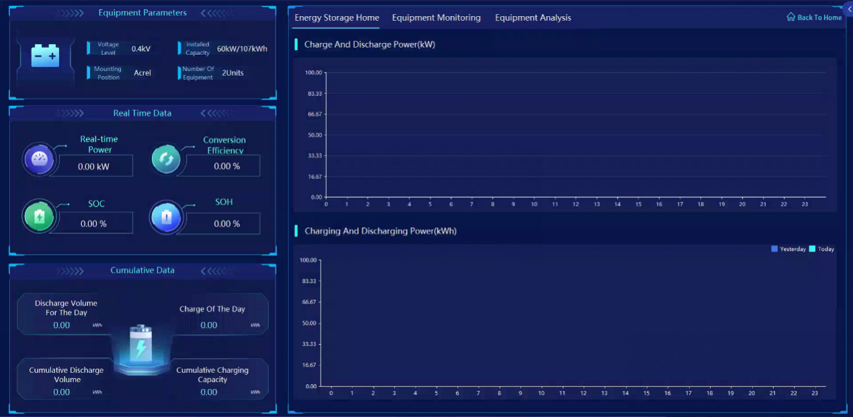
Fig. 7.9 Main Monitoring Interface of Energy Storage System

7.1.2 Photovoltaic Power System
For application in the microgrid with PV generator, the system provides the online monitoring of the PV arrays, environmental monitoring, combiner boxs, inverters, and other devices to guarantee the safe operation of PV generator.
- Measurement monitoring: environmental information such as sunshine, temperature, and wind speed, PV panel temperature, DC voltage, DC current, DC power, inverter power, etc.
- Status monitoring: AC/DC over-voltage/ under-voltage, AC/DC over-current, over-frequency /under-frequency alarm, over-temperature, over-load, leakage protection, etc.
- Capacity monitoring: real-time generating capacity of PV, total generating capacity, etc.
- Remote control: inverter start, stop
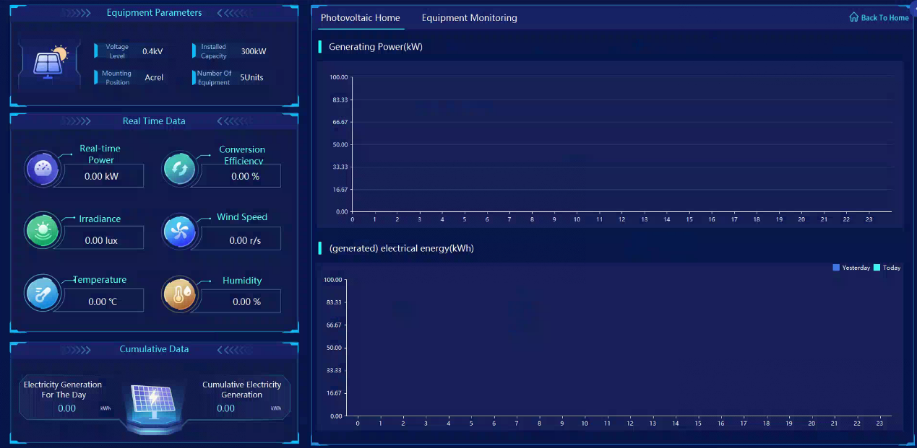
Fig. 7.10 Main Monitoring Interface of PV Power System

7.1.3 Wind Power System
For the microgrid system configured for wind power generation, it has the function of online monitoring of wind turbines, wind power grid-connected controllers, grid-connected inverters, etc., to ensure the safe operation of wind power generation.
- Measurement monitoring: temperature, wind speed and other environmental information, DC voltage, DC current, DC power, inverter power and so on.
- Status monitoring: AC/DC overvoltage/undervoltage, AC/DC overcurrent, frequency over/under alarm, over-temperature, overload, leakage protection, etc.
- Power monitoring: wind turbine real-time power generation, total power generation, etc.
- Remote control: inverter start, stop.
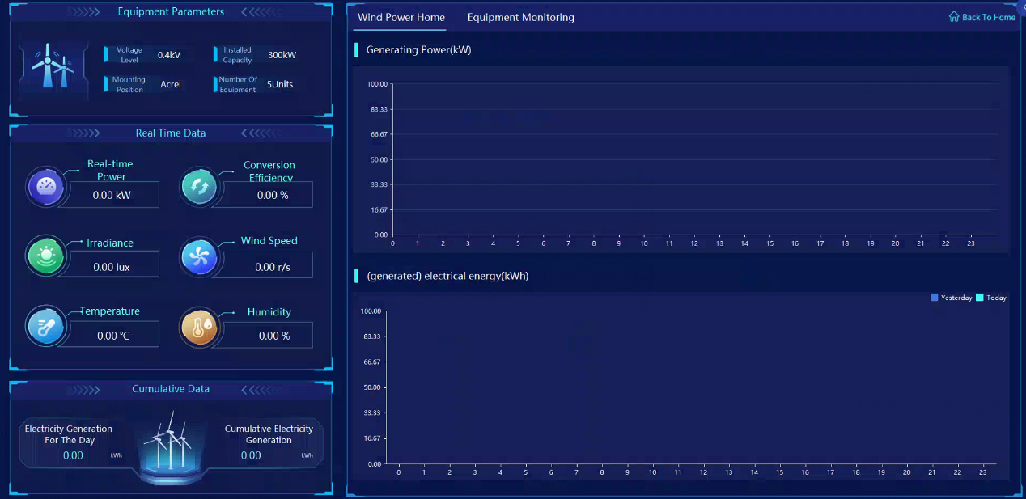
Fig. 7.11 Main Monitoring Interface of Wind Power System

7.1.4 Charging Pile System
1) Charging monitoring
The microgrid energy management system shall have the functions of providing various types of measurement monitoring, status monitoring and power monitoring of the charging pile.
- Measurement monitoring: charging current, charging voltage, charging power, charging time, SOC, battery voltage, battery temperature and so on.
- Status monitoring: charging pile status, connection confirmation switch status, output relay status, charging interface electronic lock status.
- Power monitoring: real-time charging volume during charging, charging table bottom value, transaction records.
2) Charging control
The microgrid energy management system has the function of providing all kinds of remote control of charging pile and data setting.
- Charging control: start, stop.
- Remote control: restart, upgrade.
- Data setting: time period parameter, emergency card list.
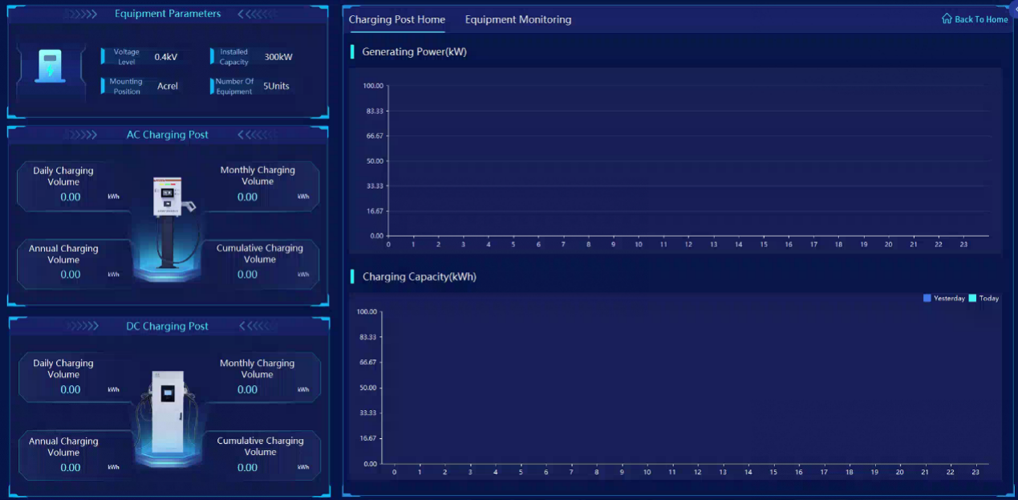
Fig. 7.12 Main Monitoring Interface of Charging Pile System

7.1.5 Diesel Generation System
For the microgrid system configured with diesel generators, it has the function of on-line monitoring of diesel generator sets, etc. to ensure the safe operation of diesel generators.
- Measurement monitoring: speed, water temperature, oil pressure, oil level, etc.
- Status monitoring: overspeed, frequency over/under alarm, over-temperature, overload, leakage protection, etc.
- Power monitoring: diesel real-time power generation, total power generation, etc.
- Remote control: start and stop of diesel engine.
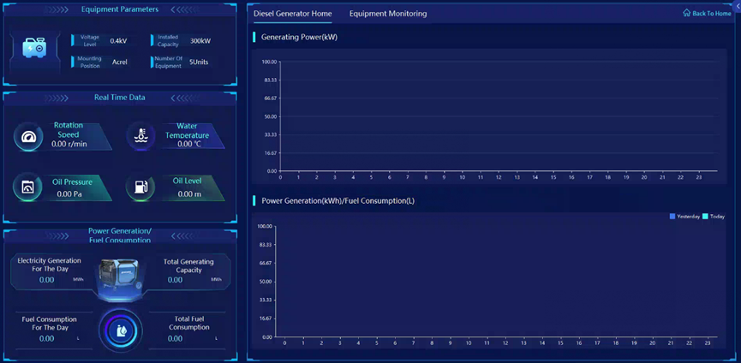
Fig. 7.13 Main Monitoring Interface of Diesel Generation System

7.2 Data Acquisition
Acquire and process real-time information such as analog data and digital data via measurement and control unit, energy storage unit, battery management system, charging pile, wind generator inverter and PV inverter.
Acquired and processed information:
- Charging power of charging pile
- Power of PV inverter、wind generator inverter
- Real-time data of battery cells such as voltage and temperature
- Current and leak current of battery module
- Fault alarm signals and protection enabling signals
Uploaded information of energy storage unit:
- Digital data: status of contactors and breakers at AC and DC sides, operating modes (e.g. on-grid, off-grid, charging, discharging and standby), status of local control handle, etc.
- Analog data: voltage and current at the DC side, 3-phase voltage, current, active power and reactive power at the AC side
- Non-electricity data: temperature of IGBT, electric reactor, isolation transformer, etc.
- Operating conditions: protection enabling signal of energy converter, incident alarm signal

7.3 Event Alarm
The microgrid energy management system has incident alarm function and the forewarning function. Incident alarms relate to the breaker tripping caused by abnormal operations and the enabling signal of protective devices. forewarning cover the deviation of general equipment, abnormal status, over-voltage, over-current, excess pressure, abnormal flow, software /hardware abnormal of monitoring system and other problems. Classify and filter relevant alarm signals as needed and assign alarm signals to various alarming windows.
The system can also send alarms for deviation of remote signaling, protection enabling, abnormal tripping and other incidents of breakers, isolators and grounding switch in the distribution circuit.
1) Primitives alarm
2) Alarm dialog
3) Real-time voice alarm for all incidents
4) SMS alarm to the defined cell phone (It need to match SMS mode)
5) Dialing alarm to the defined cell phone (It need to match call box)
6) Visible and audible alarm
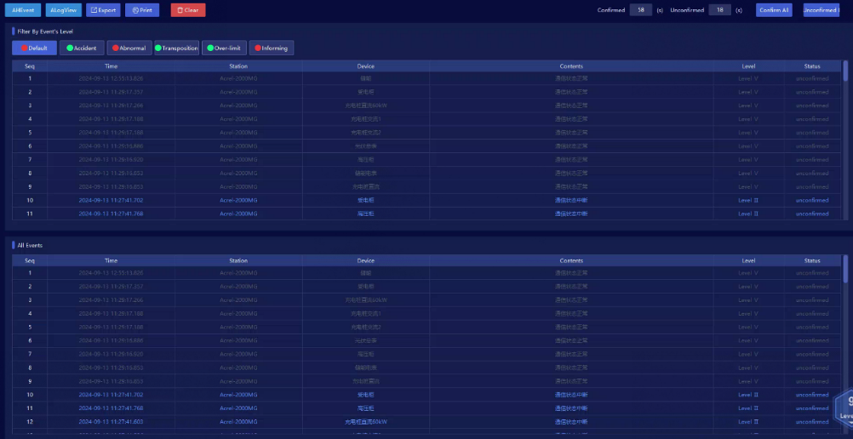
Fig. 7.14 Event Alarm Interface

7.4 Query of Historical Event
Acrel-2000MG microgrid energy management system can store and manage the event records of remote signaling displacement, protection action, accident trip, and voltage, current, power, power factor overrun, etc., which is convenient for the user to trace the system events and carry out the historical tracing, query statistics, and accident analysis. It can be queried and sorted by time, type and equipment.
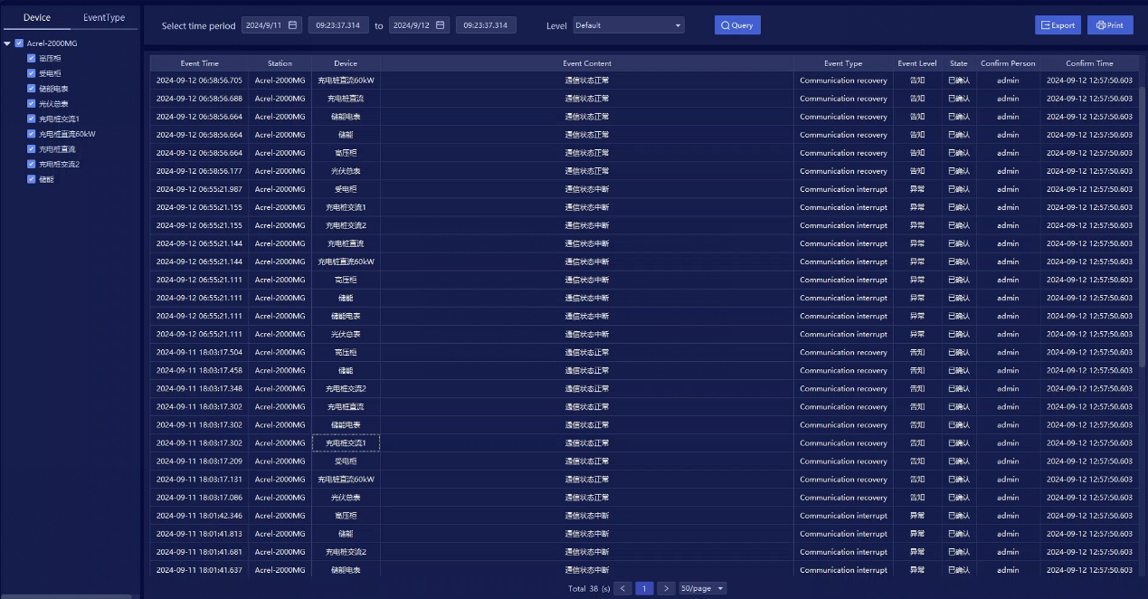
Fig. 7.15 Query of Historical Event Interface

7.5 Curve Query
Acrel-2000MG provides a curve query interface for direct access to various electric parameter curves (e.g. 3-phase current, 3-phase voltage, active power, reactive power, power factor and temperature) and statistics of the curve within the query range of the maximum value, the time of the maximum value, the minimum value, the time of the minimum value, the average value and so on.
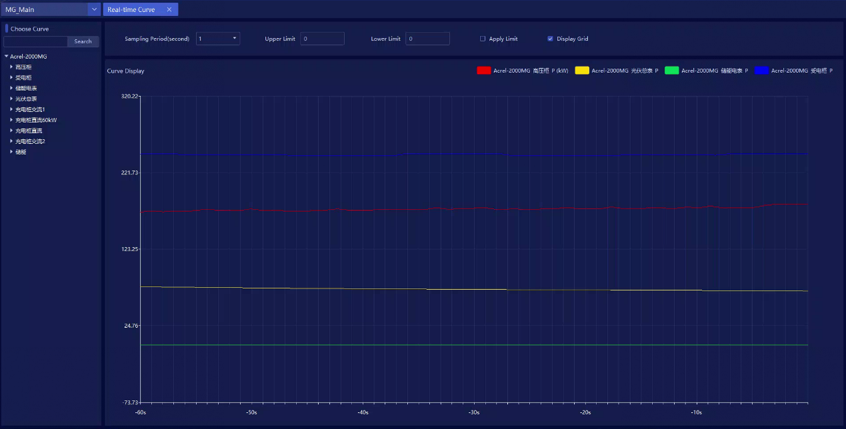
Fig. 7.16 Real-time Curve Query Interface

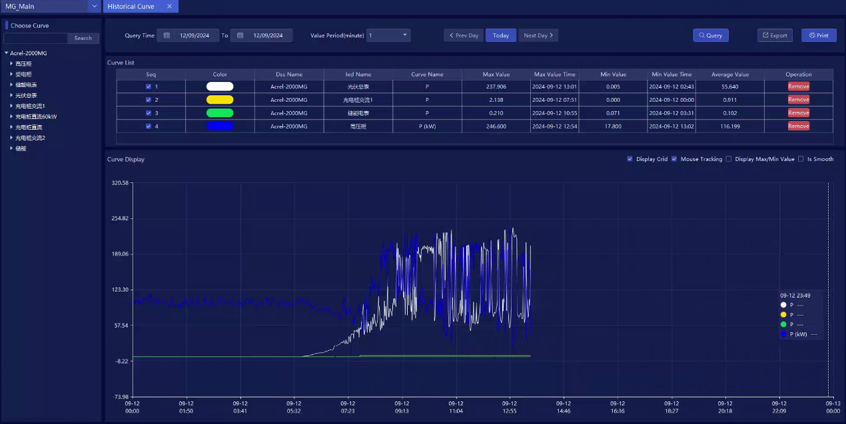
Fig. 7.17 Historical Curve Query Interface

7.6 Operation Report
Model Acrel-2000MG allows the query of running parameters of various circuits or devices within the defined time. A running report shall indicate the following electric parameters: phase current, 3-phase voltage, total power factor, total active power, total reactive power, forward active energy, temperature and others. Running reports can be searched, output or printed by day, month or year.
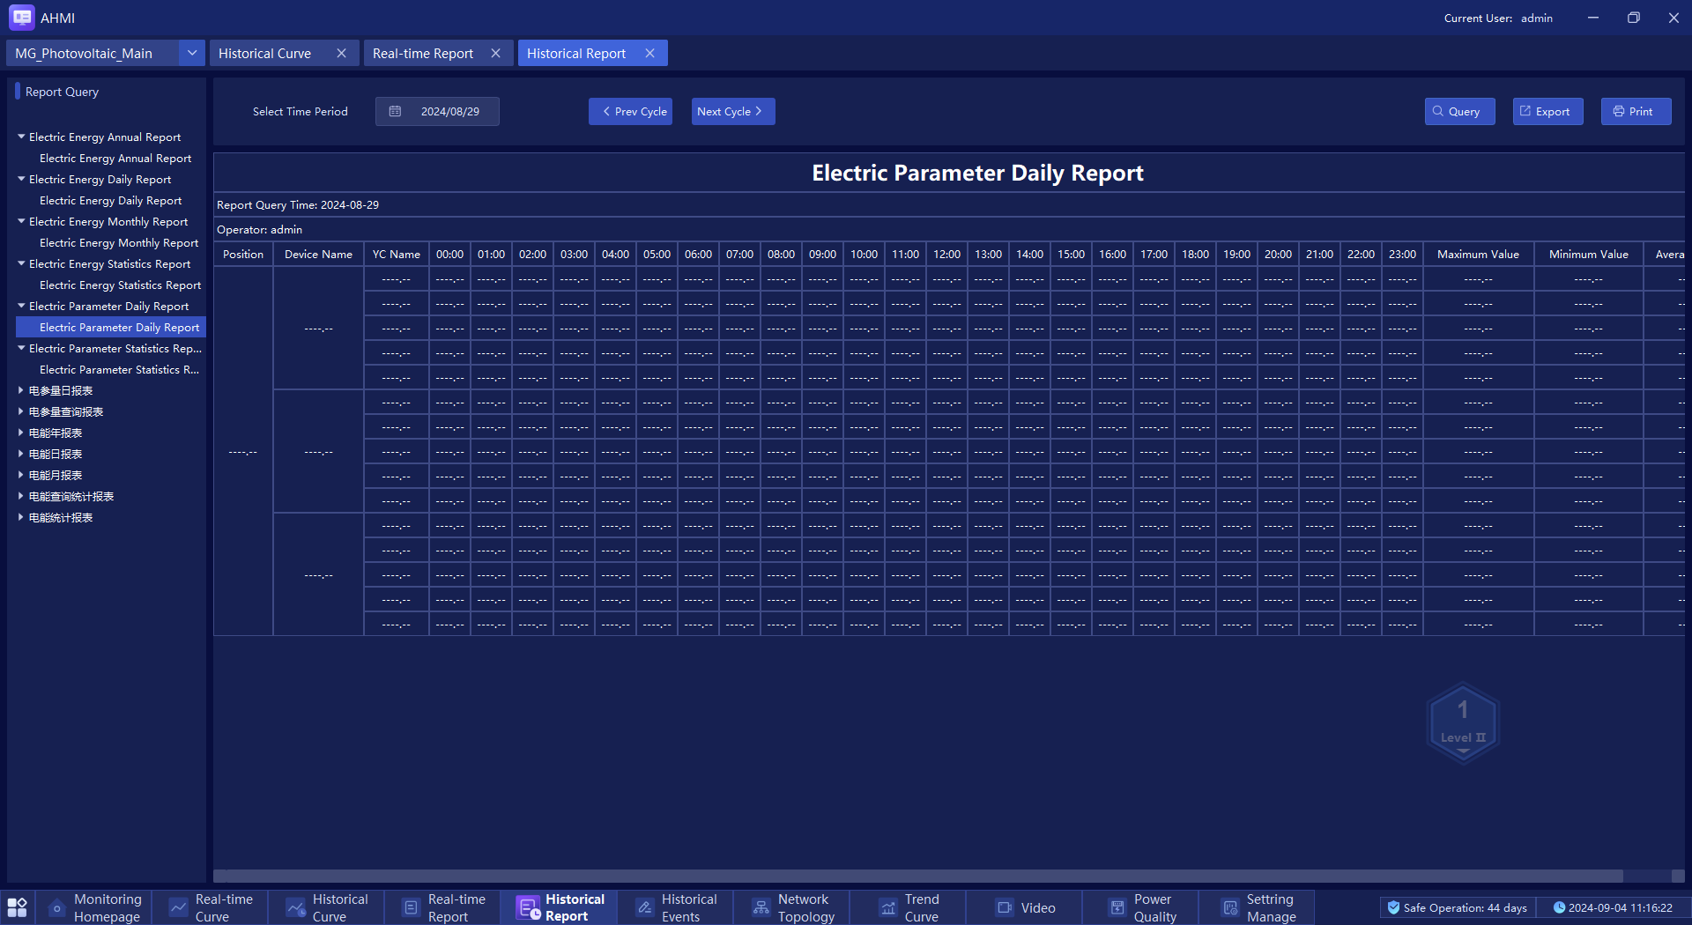
Fig. 7.18 Report Query Interface

7.7 Report Statistics
Acrel-2000MG is equipped with the function of regular meter reading and summary statistics, which allows users to query the power consumption of each distribution node for any period of time since the normal operation of the system, i.e. the statistical analysis report of the power consumption of the node's incoming power supply and that of the power consumption of each branch circuit.
- Statistics and calculation of various general operating parameters (generated power et all) of microgrid, including daily, monthly and yearly maximum and minimum values and the occurrence time, maximum and minimum values of a defined period and the occurrence time, average value, over-limit times, over-limit time, over-limit rate, pass rate, etc.
- Statistical calculations should be carried out on the power generation and total power generation of each distributed power source operating in the microgrid system, including the comparison of power generation by time period, day, month and year.
- Statistical calculations should be made on the operating conditions of the main equipment of the microgrid system, including the number of normal operations and accidental trips of circuit breakers, and the number of times capacitors/reactors are switched on and off.
- Through reports, it analyses the operating parameters of the power supply system and each loop, and forms daily and monthly operating reports, and daily, monthly and annual reports of power statistics.

7.8 Network Topology
Model Acrel-2000MG can monitor the communication status of devices connected in a micro-grid in real-time, display the complete micro-grid network structure, and identify the faulty device or component and fault location via the online diagnostics of communication status if the micro-grid runs abnormally.
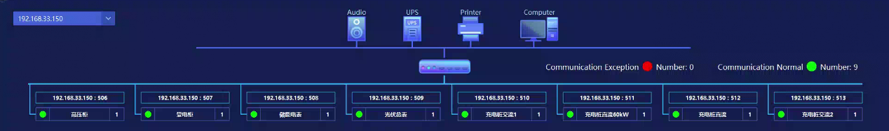
Fig. 7.19 Network Topology

7.9 Remote Control and Setup
Acrel-2000MG is capable of remote control operation for equipment throughout the entire system range. For example, the maintenance personnel of the distribution system can click the corresponding circuit breaker remote signal point to call out the remote control operation interface through the main interface of the monitoring system and can execute the corresponding operation orders of the dispatching system or the station in time.
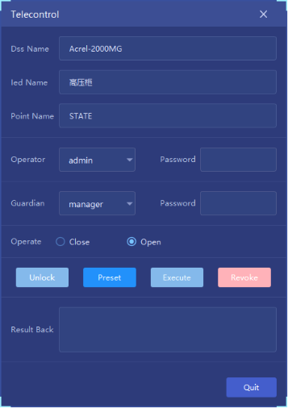
Fig. 7.20 Remote Control Interface

7.10 Communication Management
Acrel-2000MG microgrid energy management system can manage, control, and real-time monitoring of data for equipment communications within the scope of the entire microgrid system. Users can view the communication and data messages of a certain device.
It can complete the communication and data forwarding with all kinds of converters, charging piles, inverters, and intelligent electronic devices, including microcomputer protection, power instrumentation, intelligent manipulation, DC screens, analog screens, five prevention systems, and dispatching.
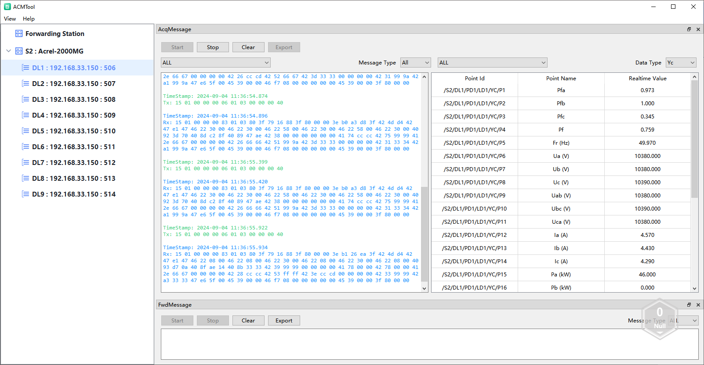
Fig. 7.21 Communication Management Interface

7.11 Energy Management
Acrel-2000MG can acquire running data of utility, PV system, energy storage system and loads. The following example describes the system operation when the utility works normally and abnormally. The system operates as follows:
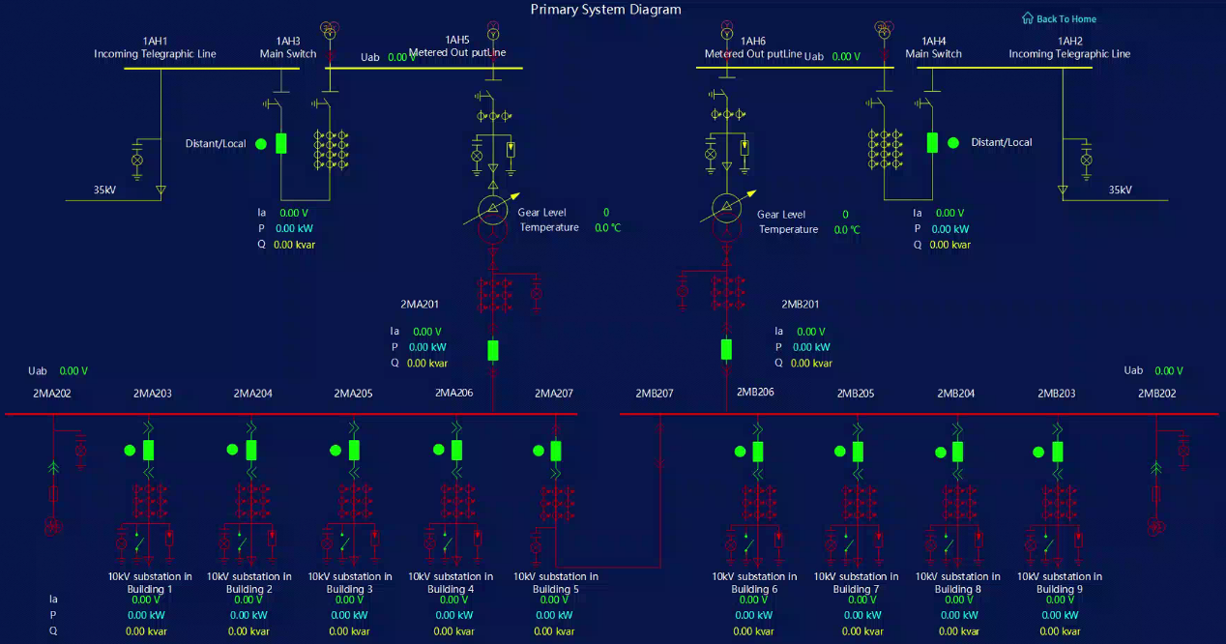
Fig. 7.22 Primary System Diagram

（1）Grid-connected mode
- When a 33kV grid works normally
① Charging: inverter power> load power and the energy storage system is not fully charged
When the sunshine is sufficient, the PV system will transmit power to loads preferentially. If there is remaining power, the PV system will charge the energy storage system. After the energy storage system is fully charged, the output power of the inverter will be reduced to avoid to transmitting power back to the 33kV grid.
② Discharging: inverter power < load power (initial discharging depth of the energy storage system is 80%)
When the sunshine is insufficient and the PV system cannot satisfy the demands of loads. The energy storage system will work with the PV system to energize loads. If the combination of energy storage system and PV system still cannot satisfy the demands of loads, the PV system, the energy storage system and the utility grid will transmit power to loads together.
Considering extreme weather conditions, the energy storage system must reserve certain power. The reserved value can be defined on the platform configuration screen.
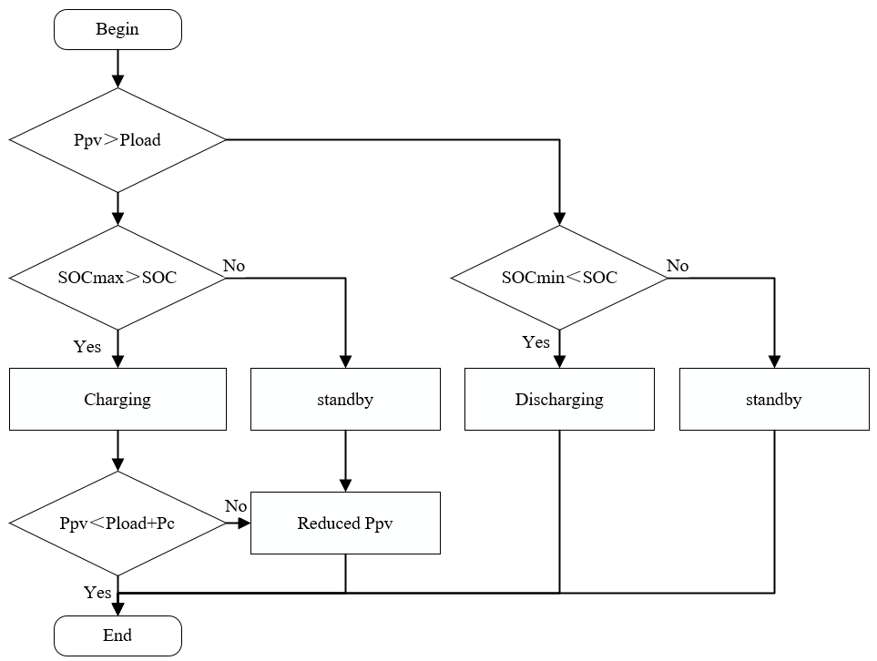
Fig. 7.23 Logical Control Flow of On-grid Running Mode
（2）Grid-islanded mode
The grid-islanded mode is classified into the scheduled grid-islanded mode and unscheduled grid-islanded mode.
- In the scheduled grid-islanded mode, send commands to breakers and PCS via Acrel-2000MG for mode switching.
- In case of unscheduled grid-islanded, the system runs the following control logic
If the voltage or frequency of the 33kV utility grid turns abnormal or there is any other fault in the grid, the islanding detector AM5SE-IS will trigger the circuit breaker in the grid-connected cabinet to open the circuit of the PV energy storage system. Second, the incoming circuit breaker of the 33kV utility grid is triggered and opened according to the data from the ABB combined protective relay. Third, Acrel-2000MG sends commands to PV circuit AMC96L to trigger the PV circuit breaker. Fourth, model Acrel-2000MG controls PCS to switch to the off-grid mode (by sending an off-grid enabling command to PCS, with reference to grid-connected / grid-islanded Switching Method and Process of Energy Storage Converter). Last, Acrel-2000MG sends a command to the distributed power circuit AMC96L and closes the circuit breaker of the PV energy storage system. Then loads run in the off-grid mode.
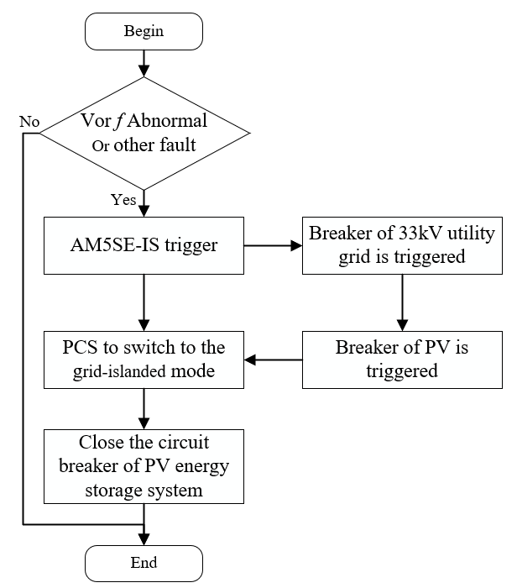
Fig. 7.24 Logical Control Flow of Grid-islanded Running Mode
When the ABB protection detects that the 33kV voltage is normal, it will back to the Acrel-2000MG. First, the system sends a command to AM5SE-IS to trip the circuit breaker of the PV energy storage system. Second, the system sends an grid-islanded shutdown command to PCS. Third, the system sends a command to the ABB protective relay to close the incoming circuit breaker in the 33kV utility grid. Fourth, Acrel-2000MG sends a command to AM5SE-IS to close the circuit breaker of the PV energy storage system. Fifth, the system sends an on-grid enabling command to PCS to switch to the grid-connected mode (see On-grid/ off-grid Switching Method and Process of Energy Storage Converter) Last, the system sends a command to AMC96L to close the breaker of PV circuit.
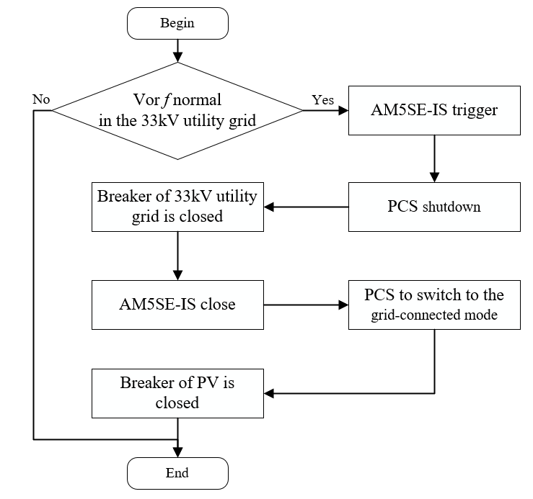
Fig. 7.25 Logical Control Flow of Grid-islanded Running Mode

7.12 User Authority Management
To ensure safe and stable operation, Acrel-2000MG boasts the function of user authority management to prevent any unauthorized operation (e.g. remote control, database modification, etc.). Define login names, passwords and authorities of different levels of users for reliable security of system operation, maintenance and management.
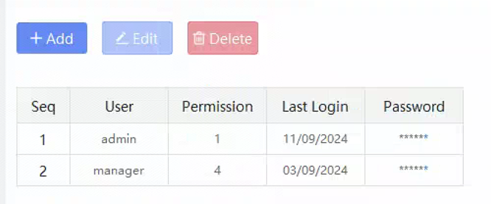
Fig. 7.26 User Management Interface

7.13 Self-diagnostics and Self-healing
- With online diagnostic capability, diagnose the system's own hardware and software operation, alarm and record when abnormalities are found, and take automatic recovery measures when necessary.
- Extend the online diagnostics function to PCBs of local equipment
- The Self-restoring should be: The system automatically resumption of operation if the general abnormal status software. When the device has a backup configuration, the online device can automatically switch to the standby configuration when a hardware or software failure occurs. The self-restoring time shall not exceed 30s.

7.14 Maintenance Function
- Online maintain the database, and add, delete or modify various data
- Offline maintain the database, and re-generate the database with reasonable initialization value
- Easily transfer historical data upon request for long-term storage
- Simply generate and edit screens

7.15 Interface With Other Devices or Systems
- The microgrid energy management system should establish communication interfaces with charging piles, energy storage PCS equipment, energy storage battery BMS equipment, wind turbine inverters, photovoltaic inverters and other individually set up equipment or systems within the microgrid system, and connect this equipment or systems to the microgrid energy management system for centralised monitoring and control, and the communication protocols should satisfy the requirements of standard communication protocols for power systems.
- The microgrid energy management system shall ensure data consistency and functional integrity when implementing interfaces with the above devices or systems.

