Multi-frequency spectral anti-photo system

Table of Contents
I. The significance of the existence of confidential products 。。3
II. Market Environment Analysis 。。。。。。。。。。。。。。。。。3
III. Product Overview。。。。。。。。。。。。。。。。。。。。。。 6
2.1 Product Functions 。。。。。。。。。。。。。。。。。。。。。。7
2.2 Product Advantages and Features 。。。。。。。。。。。。。。。8
2.3 Actual Application Effect Diagram 。。。。。。。。。。。。。。9
2.4 Product Specifications 。。。。。。。。。。。。。。。。。。。10
Product Configuration 。。。。。。。。。。。。。。。。。。。。。11
V. Product qualification 。。。。。。。。。。。。。。。。。。。。11
Application places 。。。。。。。。。。。。。。。。。。。。。。。12

I. The significance of the existence of confidential products

Confidentiality products, also known as anti-leakage products, is to avoid the leakage of important classified places, such as: government agencies, confidential meeting rooms, confidential key parts of the state secrets of the workplace of the important documents, information, electromagnetic signals and other information leakage, and the use of scientific and technological means, and can effectively and efficiently reduce the risk and safeguard security
II. Market environment analysis
With the rapid development of the Internet and the take-off of science and technology, China has stepped into the era of big data information technology, everyone has become a data source in the era of big data, information transfer and diffusion into an explosive growth, a very small information dynamics, instantly will be passed to any corner. At present, there are numerous devices with photography and photo-taking functions, intelligent wearable devices are also highly popular, and the high degree of integration of photoreceptor chips and the reduction of the volume have accelerated the birth of many intelligent terminals (e.g., smart video glasses, smart phones, smart video wristwatches, etc.). At the same time in the development of people's science and technology has also led to the rise of clandestine recording equipment (such as: pinhole camera, clandestine hat, clandestine button, with clandestine recording function of the ring, clandestine bag, clandestine tie, clandestine contact lenses, etc.).
Party, government, military and other relevant classified units have been realized paperless office, the corresponding supporting anti-disclosure management software also came one after another. Due to technical constraints, to prevent the final display terminal leakage of effective technical means of control is unprecedented, the current market can only form a deterrent to prevent the screen photo technology also belongs to the basic mode of mending the fold, such as: in the classified documents and related classified images plus watermarks to facilitate the leakage of the trace after the trail to find traces, but such a technology is only to play a retrospective role and did not do to truly prevent leakage of confidentiality. The watermarking of classified documents and related classified images is easy to find after the leakage. After the leakage of documents and pictures after modification and ps processing can achieve the effect of untraceable, so the current classified units in the display terminal link occurred in a number of leakage events.
Nowadays, the pinhole camera, that is, ultra-miniature camera variety, can meet the information theft of the person's various needs. There are cartoon pendants, lighters, watches, hooks, sockets, pens, buttons, etc., seriously threatening the security of confidential information.
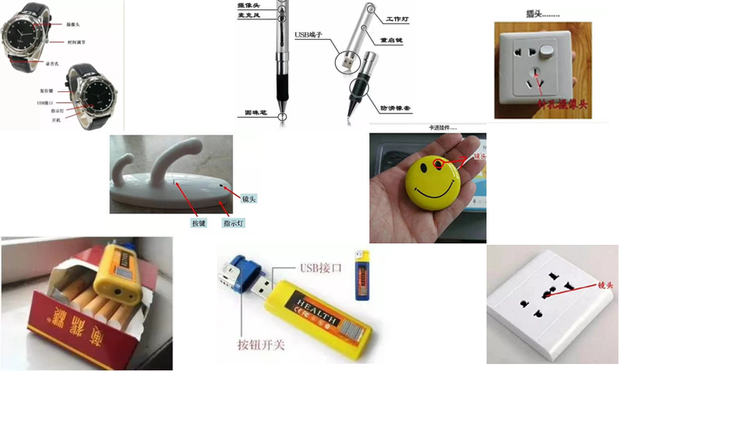
Society due to pinhole cameras caused by the leakage of events are also common. 2011 Fudan University, the first independent enrollment examination ended just five minutes later, there are real questions appeared in a special sale of various types of examination questions on the website. In less than 24 hours, the name of the 2011 Fudan level test questions (2011 Fudan University independent enrollment thousand points test questions and answers) free download “download section, is clearly arranged in the website to download the first position. The matter was then confirmed by the Fudan Admissions Office. The school said that the evening after the end of the examination, the school has been on the network to monitor the site, the person in charge of the Admissions Office said “from the photo situation, it is estimated to be in the examination room by the candidates with a pinhole camera shot.” In the face of such a severe market environment, how to ensure the security of information has become the first of many computer software companies to overcome the problem.

Today for the secret carrier and information security, confidentiality measures have the following means:
1, magnetic media: magnetic media in the application of the main role in the storage of data (such as computer hard disk, mobile hard disk, disk, etc.). Preventive measures for magnetic media are: prohibit the use of the Internet, prohibit private copying of stored information, data leakage prevention software, computer file encryption software, data protection software.
2, paper media: paper media refers to the printing or printing or even handwritten on paper archives (such as documents, manuscripts, files, telegrams, etc.); for paper media precautions are: prohibit personnel from entering and exiting the work area with paper, waste media can not be sold twice, regular recycling and destruction.
3, display carriers: display carriers are certain electronic documents through a specific transmission device to the screen and then reflected to the human eye display tools (such as liquid crystal displays, LED displays, projectors, etc.).
Preventive measures for display carriers are:
1、Watermark encryption
“Watermark” encryption will be some identification information (numbers, patterns, two-dimensional code) directly embedded in the carrier (including multimedia, documents, software, etc.) or indirectly expressed (modification of the structure of a particular region).
Advantages: a. Can produce visible or invisible marking on the main document information without affecting the use of the case.
b, hidden watermarks can be traced to the leaker
Limitations: a, not flexible, only when the information entry is completed using technical means to add watermarks, can not be edited or changed at any time to encrypt the document.
b, hidden watermarks can be traced to the leaker is only mending the fold.
2, computer screen anti-peep film
“Computer screen anti-peep film” using ultra-fine louvers (MICROLOUVER) optical patented technology, so that the screen displays information exclusively for the user to read in the front, the visual area is 60 degrees, anyone in the two sides of the side can only see the black screen, mostly used in notebook computers.
Advantages: a. Can be formed in addition to the user other than isolation, to a certain extent, to ensure the confidentiality of information.
Limitations: a, the use of object limitations. Only for laptop or desktop computers and other equipment with a monitor. For the projector class equipment can not do information protection.
b. The leaker can still take pictures from the front to steal information.
So now there is a better means?
Our company according to the above prominent market problems, after three years of directed research and development, the use of independent patented technology “multi-frequency spectroscopy” technology successfully developed a display of anti-photography system, named “multi-frequency spectroscopy anti-photography system”, for short! “Anti-snap system” for short. At present, the anti-photo system is mainly targeted at the equipment for LCD monitors, projectors, large screen equipment, to truly realize the photographic equipment can not see the role of the camera can not be seen, only classified personnel in the application of “multi-frequency spectroscopy” auxiliary equipment can see the real classified documents and files and pictures and videos and other content, and at the same time to achieve in the prevention of photo mode At the same time, in the mode of preventing photography, each person can only see the content of their own display device, so that all the classified computers in the same area can see the effect of the classified content of the computer user himself. This product makes up for the loopholes of “anti-peep film” and “watermark”, which are the two means of preventing leakage; encrypts the transmitted signal information in a brand-new way, and effectively prevents cell phones, cameras, camcorders, pinhole cameras and any other devices that can be used for forensic photo-taking from taking pictures at any angle, at any time and at any time. The equipment in any angle, any time and place through the photo function to record information intentionally or unintentionally caused by the leakage of confidential information.


III. Product overview
“Multi-frequency Spectral Display Anti-camera System is composed of a host computer, one or more pairs of special glasses and two HDMI connecting cables. This product is installed in the middle of signal output and content carrier, with a new hardware processing method to encode and encrypt the output signal, the user through the special glasses provided for the encoding and resolution of the signal, presenting confidential information content. It makes the signal display device and the input device present different contents, causing interference to the naked eye and the direct access to the information of the shooting device, and only by correctly wearing the matching filter glasses can the correct confidential information be recognized.
The product can be connected to multiple devices through the network, and by a host management terminal to control the use of the whole set of anti-filming system permissions and the use of time periods. Users install the anti-filming system, such as no anti-filming needs, you can independently close the anti-filming function of any connected device; when there is anti-filming needs, can also be opened at any time. Users can independently set the system according to the demand for the use of the time range, in the set time period outside the output terminal for the normal display device. Each signal output contains an independent QR code, so if the display device is photographed, the source of leakage can be traced according to the QR code intime.

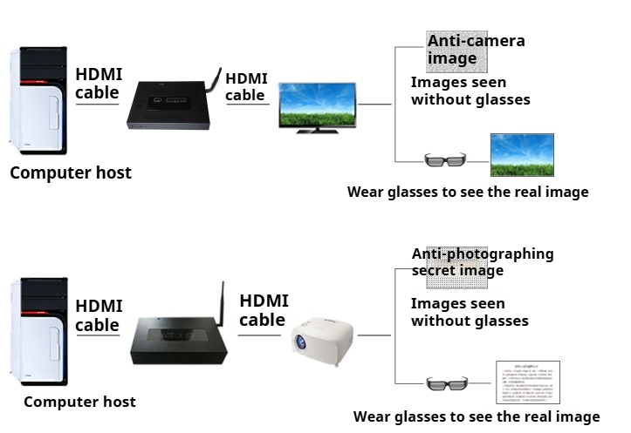

2.1 Product Functions
● anti-photo function: This product is mainly for projectors, LCD monitors and other equipment, really realize the purpose of letting the photo equipment can not be photographed, can not be seen. Whether through the naked eye, cell phone camera function, cameras, video cameras, pinhole cameras, and any other equipment that can be forensically photographed at any angle to see and shoot are interfering with the image, can not see the hidden real content.
● anti-electromagnetic leakage function: this product first of all the data signal coding and processing, and encryption of information, if the information is stolen, the theft system can only restore the encrypted information, so as to play a good protective effect on sensitive information. This software does not access the system host, only as a debugging anti-tapping glasses access to use alone, will not have any interference with the original system.

2.2 Product Advantages and Features
● Plug and Play: Connect the confidential computer host and the display side (projector or computer display) respectively, turn on the power and you can use it.
● No need to install software: no application software is installed in the confidential computer host, there is no possibility of software leakage. Complete physical isolation.
● special glasses permissions: the random matching of special glasses can be set up to use the permissions, even if lost or stolen will not cause leakage of confidentiality occurs.
● No training: This product is plug and play, no need for specialized training can be used.
● network centralized control: through the network to connect multiple display devices, by a network terminal device unified control, according to the user's needs at any time to control the use of the connected equipment anti-tap function on and off and the use of time.
● does not change the original settings: this “multi-frequency spectral display anti-filming system” using external hardware connection, the product host and the computer through the HDMI cable connection, without the need to install any software. Neither change the structure of the user's original hardware facilities, and will not change the original use of the habit.
● Interference image can be changed by yourself: the interference image presented by the terminal display device connected to this product is not fixed, and users can change it according to their needs to increase the confidentiality factor.
● control multiple display devices: this system can be connected to multiple devices through the network, by a network management terminal centralized management of the entire system, the user can use the demand for self-opening or closing any of the connected devices of the anti-shooting function; the user can also adjust the anti-shooting function of the use of the time period, in the time period outside the no need for any operation, the display of terminal equipment that is the normal equipment, no anti-shooting function. No anti-take function.
● QR Code Tracking: Any device installed with this system carries an independent QR code on the interference image, if its device is photographed, it can be tracked to the corresponding display terminal according to the QR code on the photo.
● Fingerprint identification system: This product can be installed with fingerprint identification system according to the user's demand, realizing the exclusive use of the device to prevent others from stealing the glasses and then using them resulting in the leakage of confidential information.

2.3 Actual application effect diagram

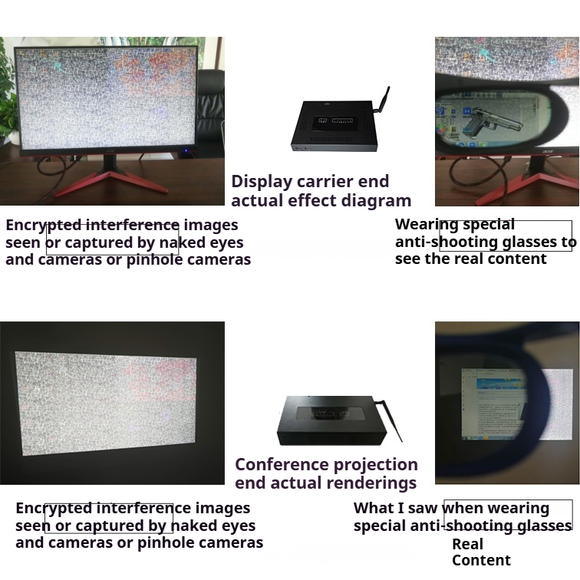

2.4 Product Specifications
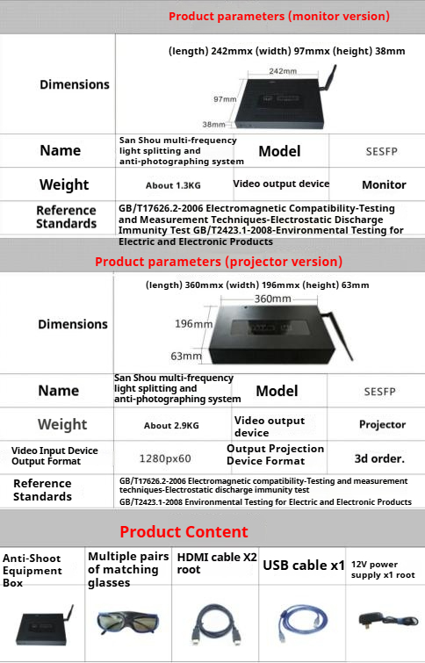

IV. Product configuration
This product is embedded with a variety of modules to meet the various needs of users.
“Multi-frequency spectroscopy” module: in the classified computer host and monitor connection with multi-frequency spectroscopy module to change the display mode of the classified computer to realize the ‘multi-frequency spectroscopy’ display mode, such as manually turn on this mode after the monitor to enter the anti-shooting mode.
Network wake-up module: the built-in network wake-up module is the expansion module of the “multi-frequency spectroscopy” module, and the application of the network expansion module can realize the automatic switching of the anti-shooting mode and the non-anti-shooting mode, so that when the classified computer opens the classified documents, the network module can automatically wake up the “multi-frequency spectroscopy” module to realize the anti-shooting mode. When a classified computer opens a classified document, the network module can automatically wake up the “multi-frequency spectroscopy” module to realize the anti-tapping.
Terminal centralized management module: The main function of this module is to realize the module management function of centralized awakening and mandatory stopping function of grouped “multi-frequency spectroscopy” application module, which is convenient for the centralized opening of using units in special time periods, such as: in the environment of having outsiders to visit and leaders to inspect.
“Multi-frequency Spread Spectrum” Network Monitoring Module
“Multi-frequency Spread Spectrum” Module Centralized Upgrade Module
“Multi-frequency Spread Spectrum” module external equipment management module

V. Product qualification
- CMA Electromagnetic Compatibility, Environmental Inspection Report
- CMA Ministry of Public Security test report
-  utility model acceptance notice
-  Invention Patent Acceptance Notification
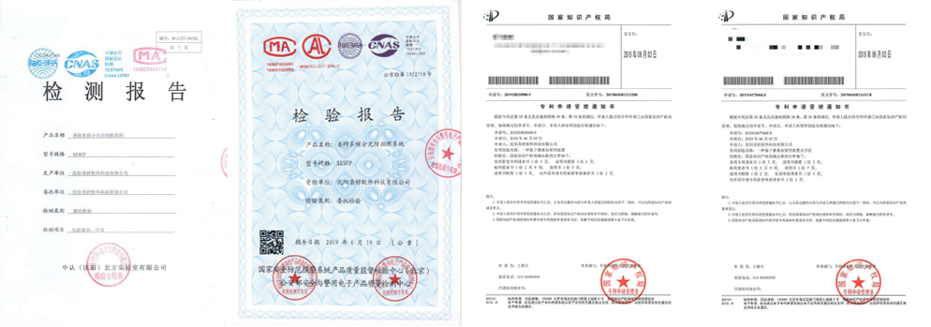

VI. Places of application
This product is mainly used in the national government agencies at all levels, the People's Liberation Army military, armed police, national security, public security, customs, scientific research institutes and other units of the confidential conference room, combat command centers, confidential confidential machine office and other places. It can also be used to prevent commercial spies from taking pictures and recording the theft of secrets.

